Proposal Bids – Screenshot

## Screenshot 1

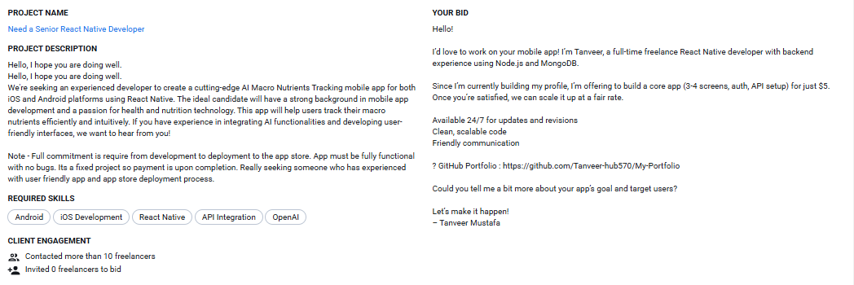

## Screenshot 2

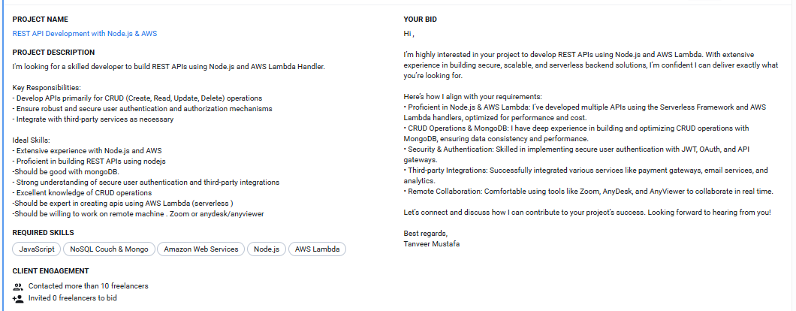

## Screenshot 3

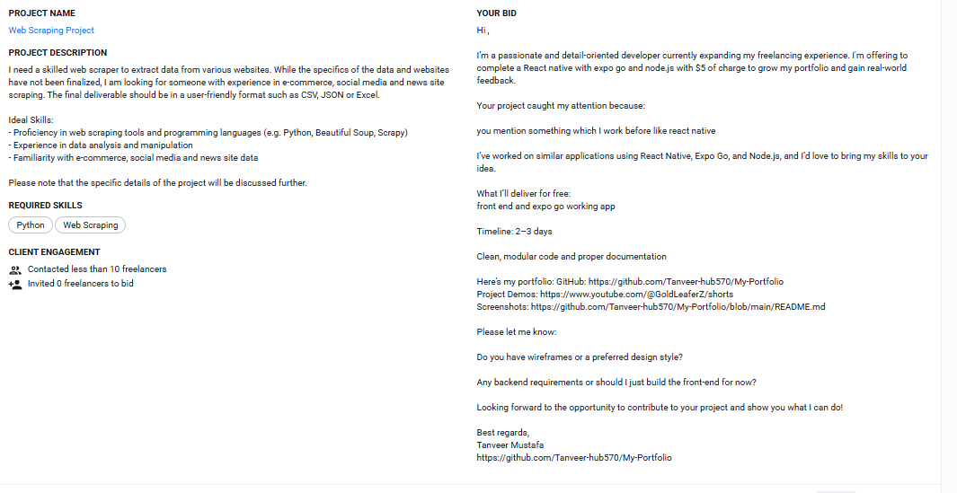

## Screenshot 4

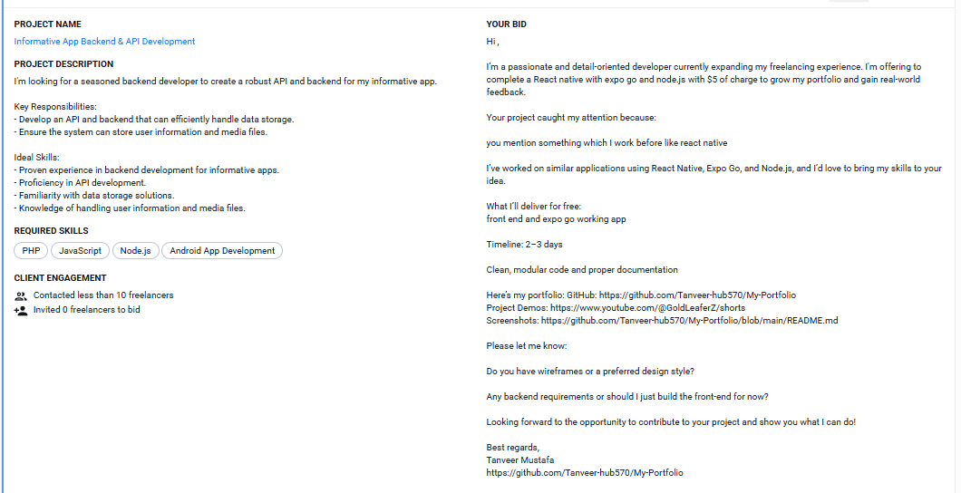

## Screenshot 5

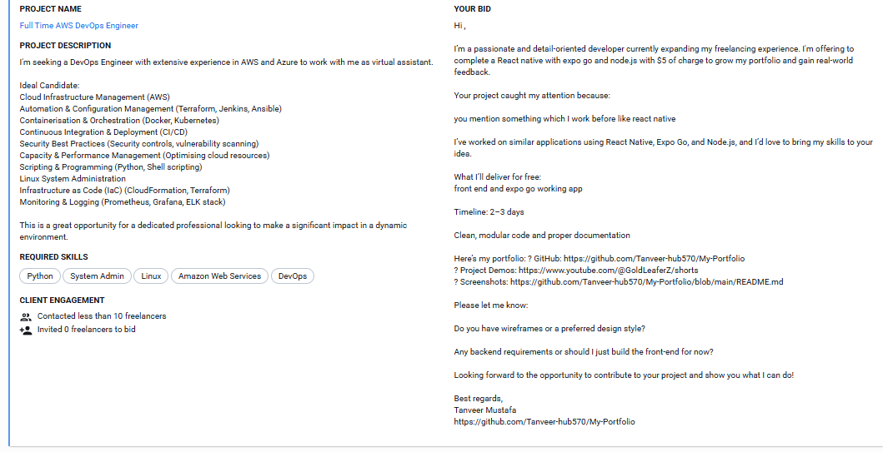

## Screenshot 6

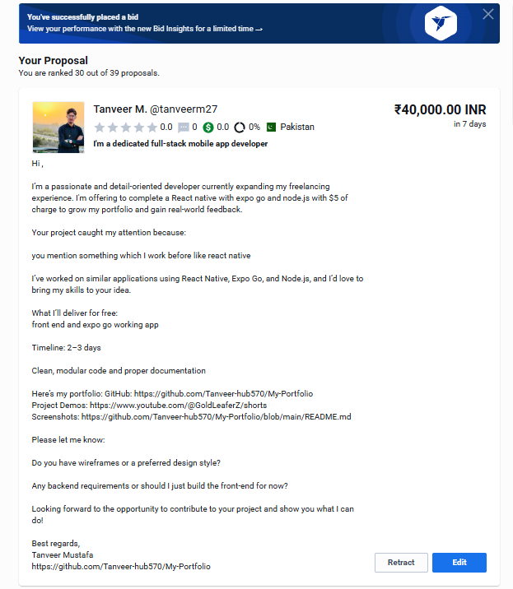

## Screenshot 7

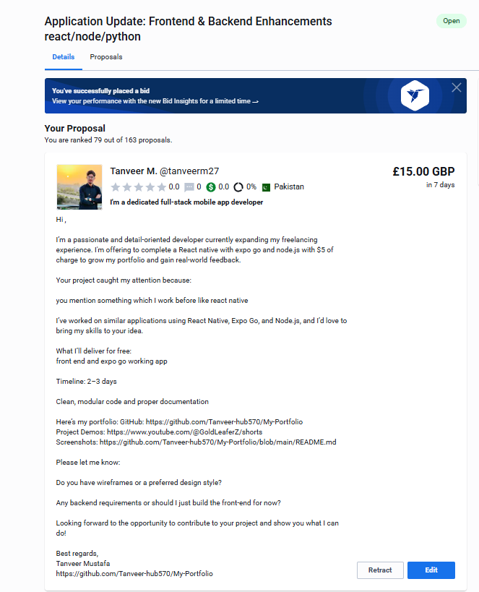

## Screenshot 8

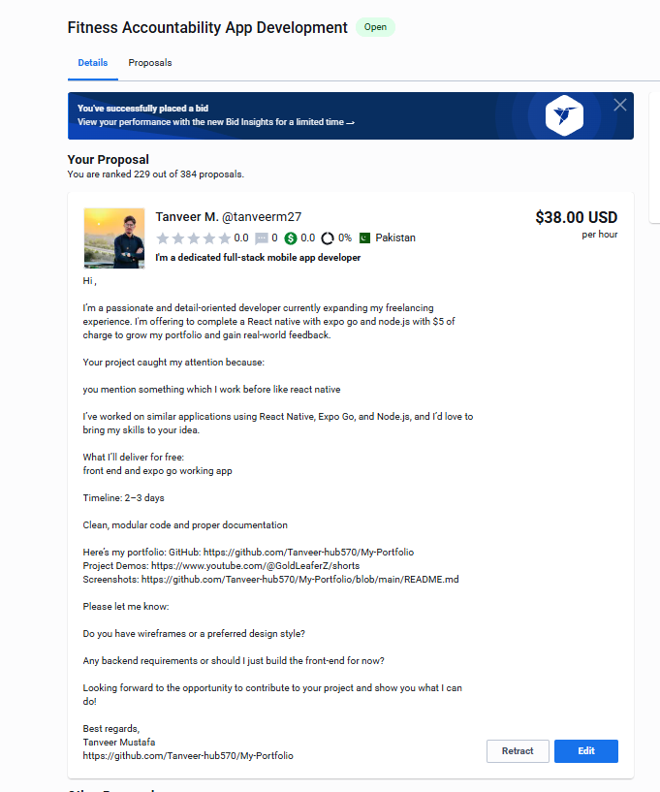

## Screenshot 9

[Insert Screenshot Here]

## Screenshot 10

[Insert Screenshot Here]

## Screenshot 11

[Insert Screenshot Here]

## Screenshot 12

[Insert Screenshot Here]

## Screenshot 13

[Insert Screenshot Here]

## Screenshot 14

[Insert Screenshot Here]

## Screenshot 15

[Insert Screenshot Here]

## Screenshot 16

[Insert Screenshot Here]

## Screenshot 17

[Insert Screenshot Here]

## Screenshot 18

[Insert Screenshot Here]

## Screenshot 19

[Insert Screenshot Here]

## Screenshot 20

[Insert Screenshot Here]